ICIN Bank online-banking project Screenshot

Contents

1.Folder Structure: **2**

2.LOGIN Page: **16**

3.SignUp Page: **16**

4.AFTER-LOGIN Page: **17**

5.OPTION Page: **18**

6.ACCOUNT OPTION Page: **18**

7.Transform Page: **18**

8.AFTER TRANSFER: **20**

9.ADD RECEPTION: **22**

10.APPOINTMENT: 23

21.ADDING RECEPTIONS: 30

22.WITHDRAW: 31

GITHUB LINK: <https://github.com/Sai153793/capstone-project-ICIN-online-banking.git>

# Folder Structure:

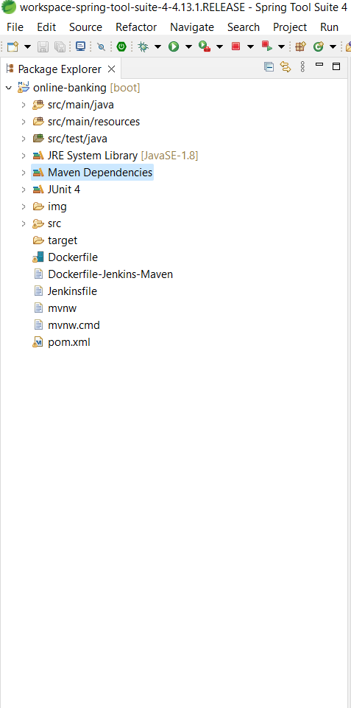

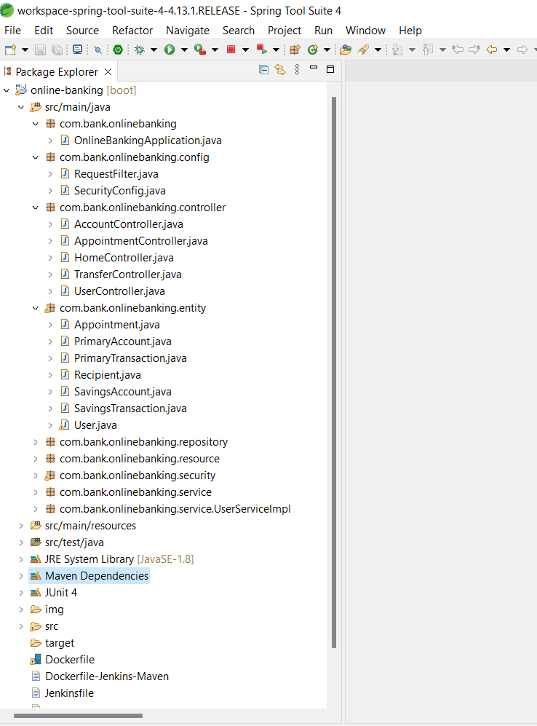

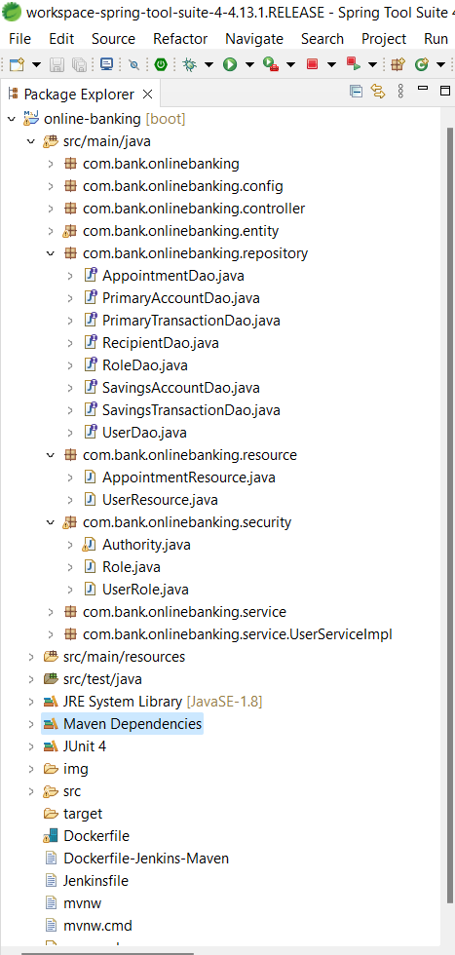

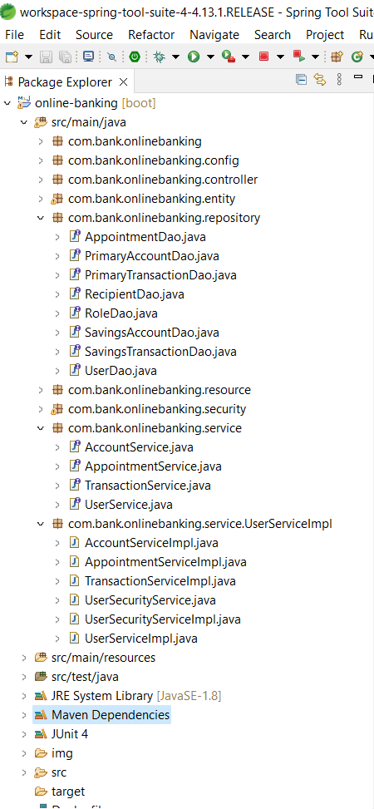

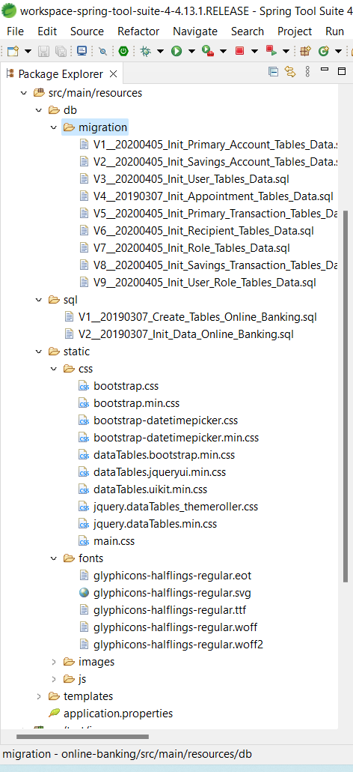

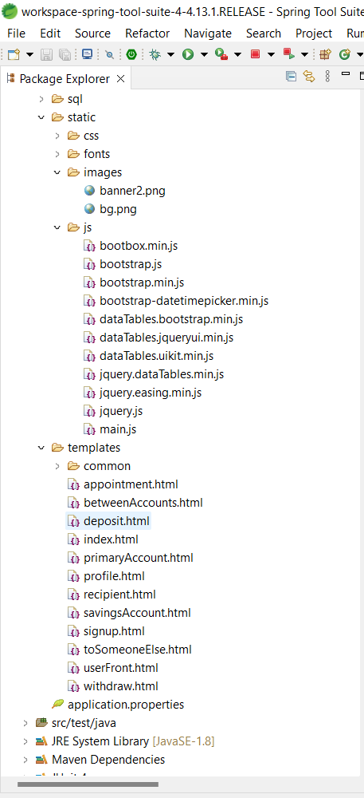

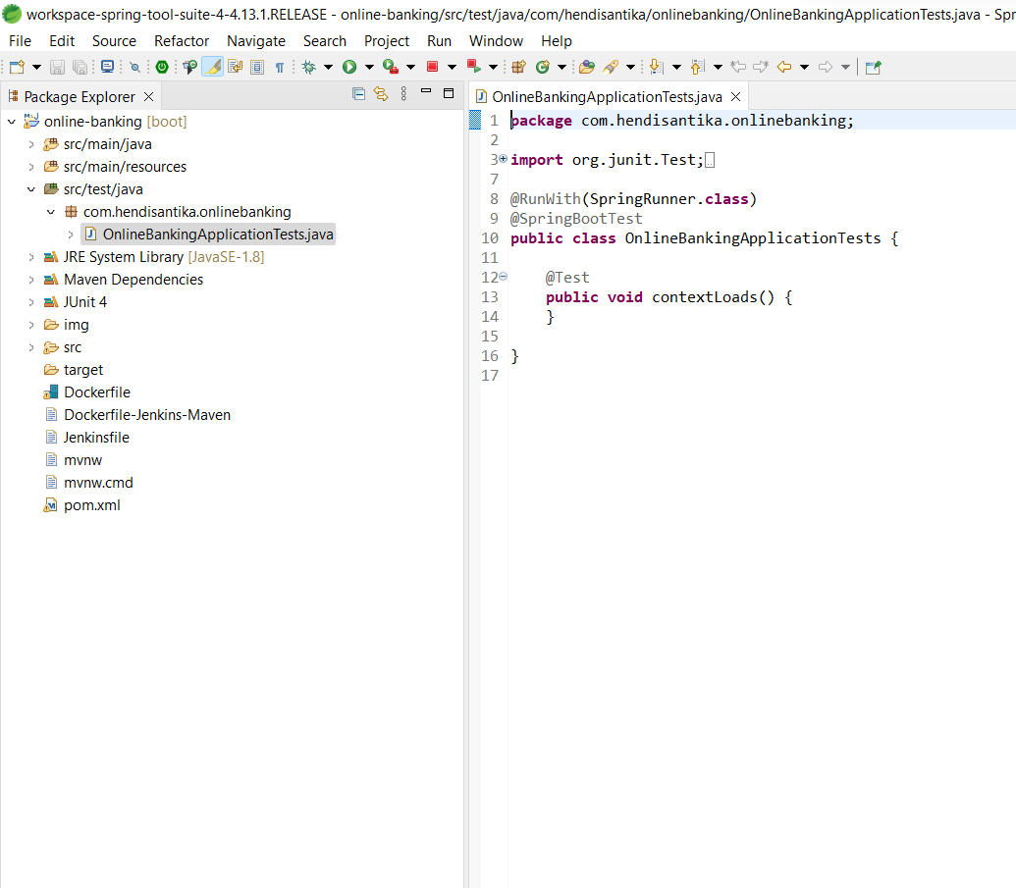

# 

# **LOGIN Page:**

# 

# **SignUp Page:**

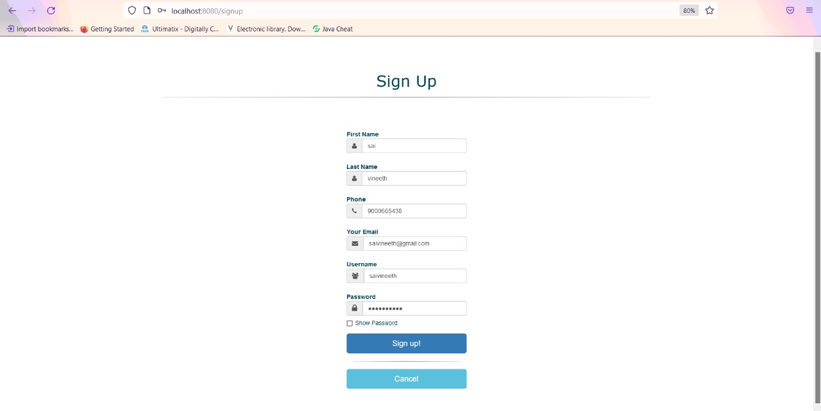

# 

# **AFTER-LOGIN Page:**

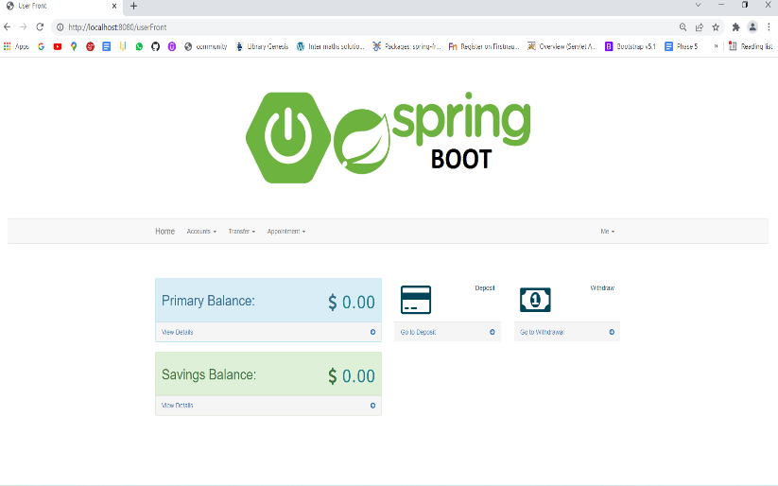

# **OPTION Page:**

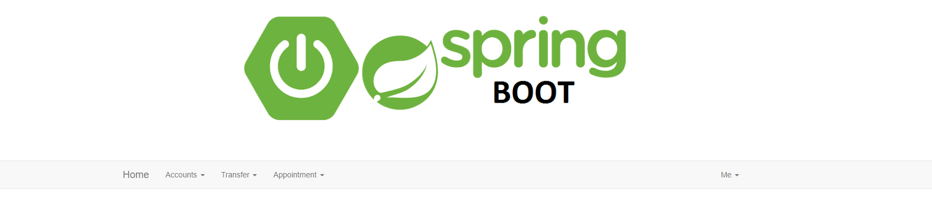

# 

# **ACCOUNT OPTION Page:**

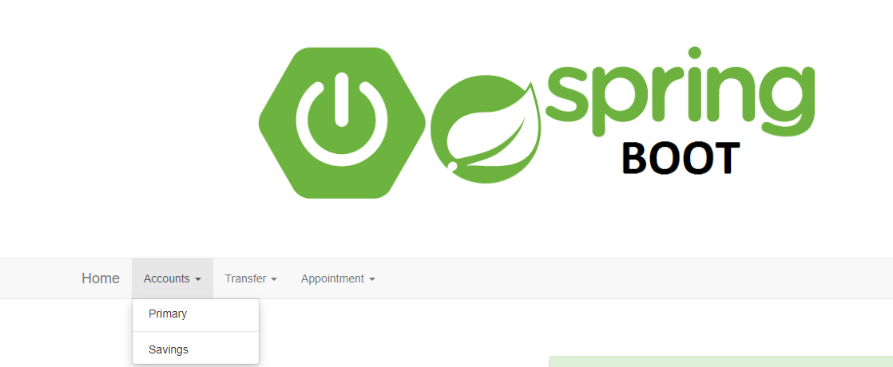

# **Transform Page:**

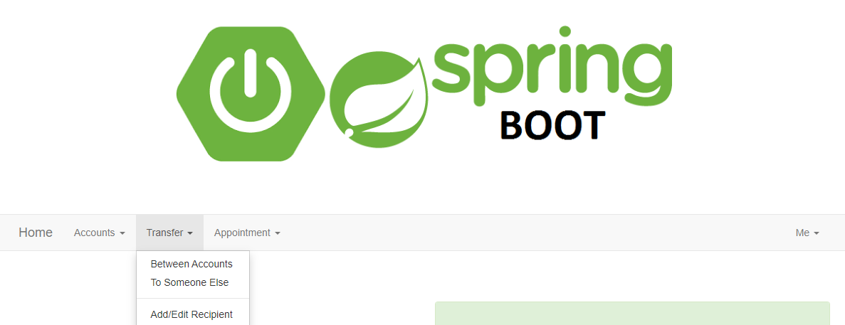

# **Between Accounts Page:**

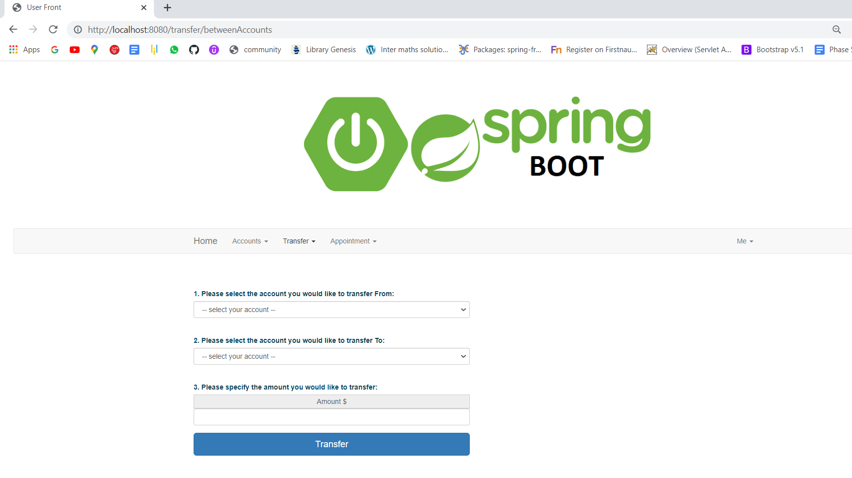

# **To Someone Page:**

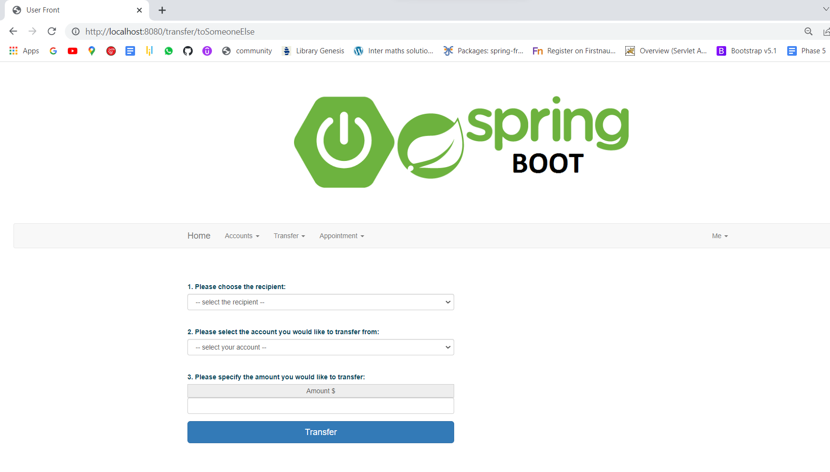

# 

# **AFTER TRANSFER:**

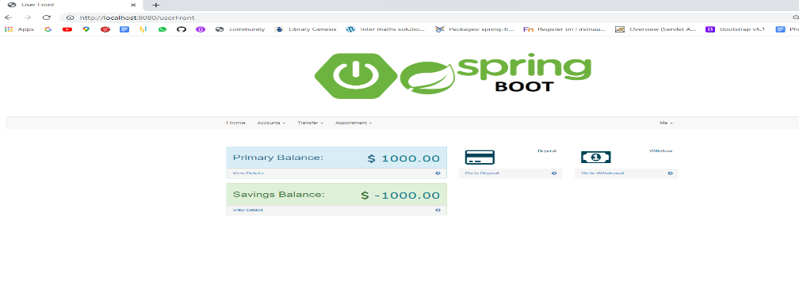

# 

# **11. ADD RECEPTION:**

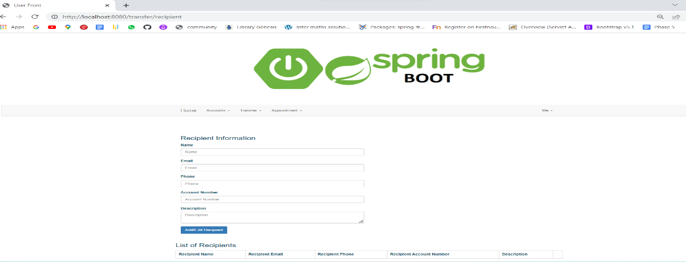

# 

# **APPOINTMENT:**

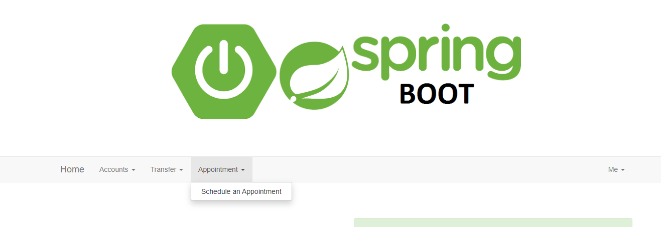

1. **DEPOSITE:**

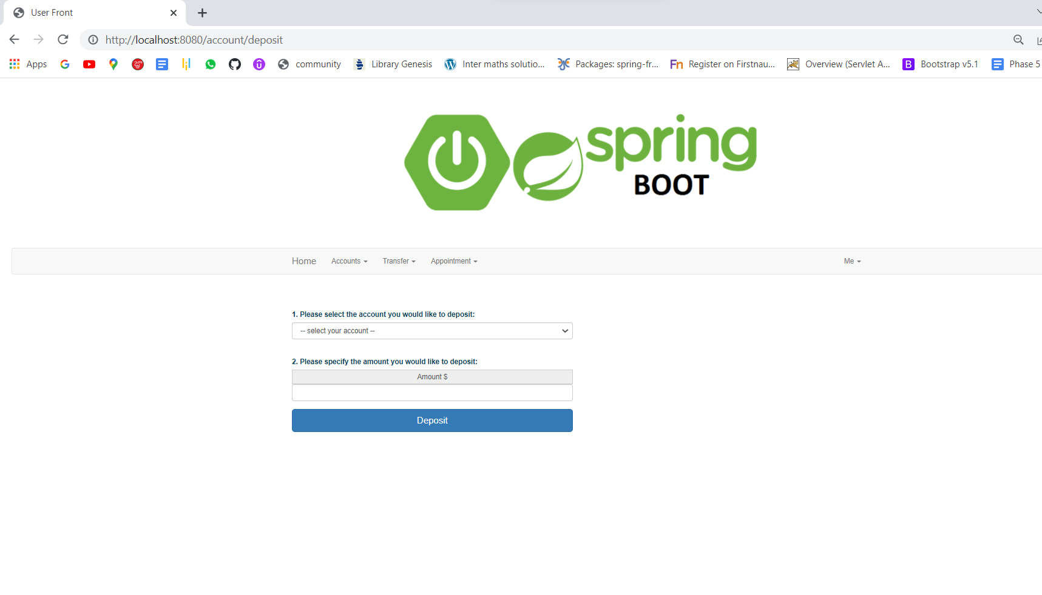

1. **DEPOSITE AFTER:**

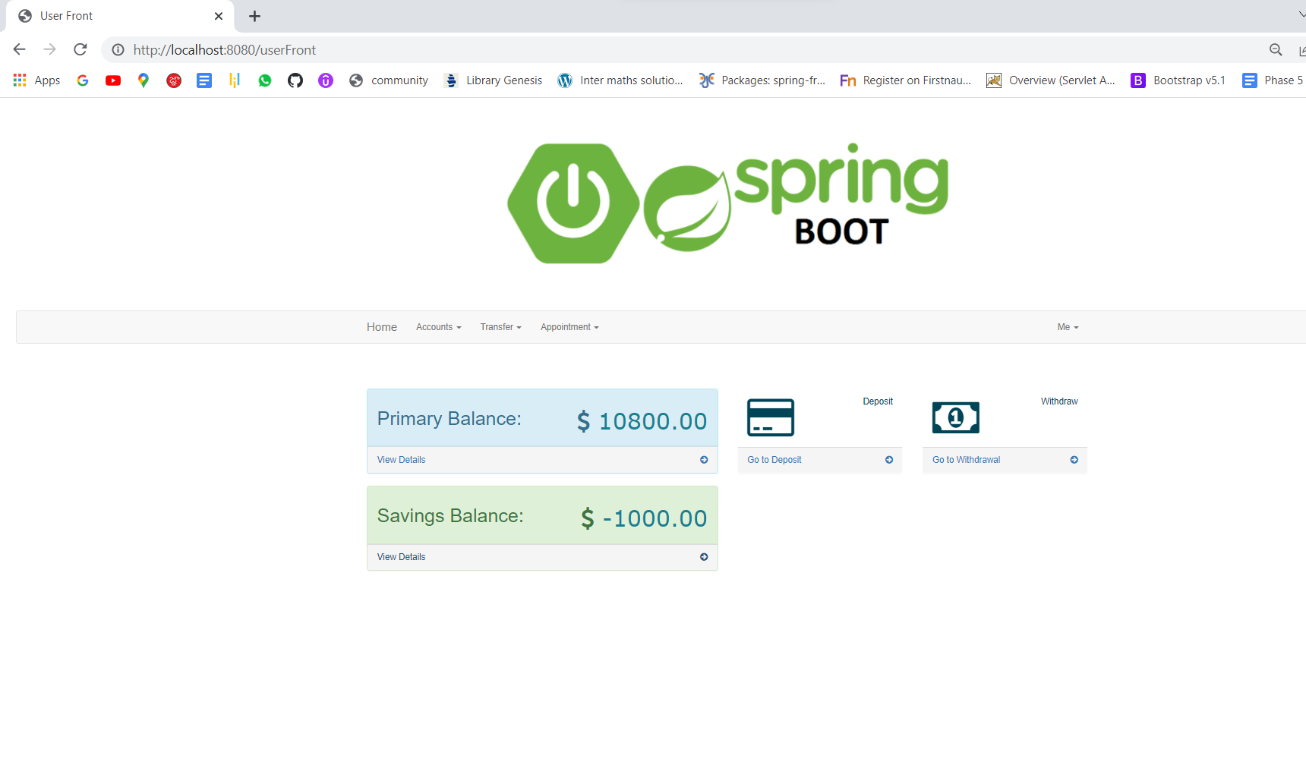

1. **PRIMARY BALANCE:**

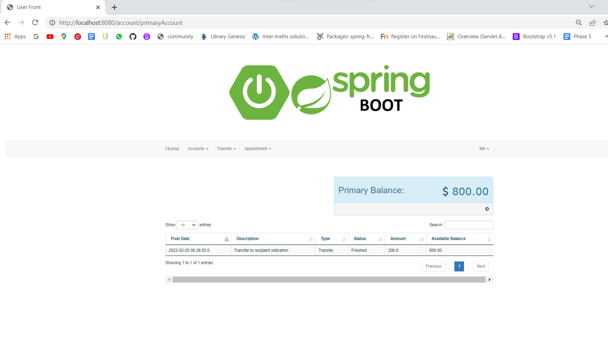

1. **SAVINGS BALANCE:**

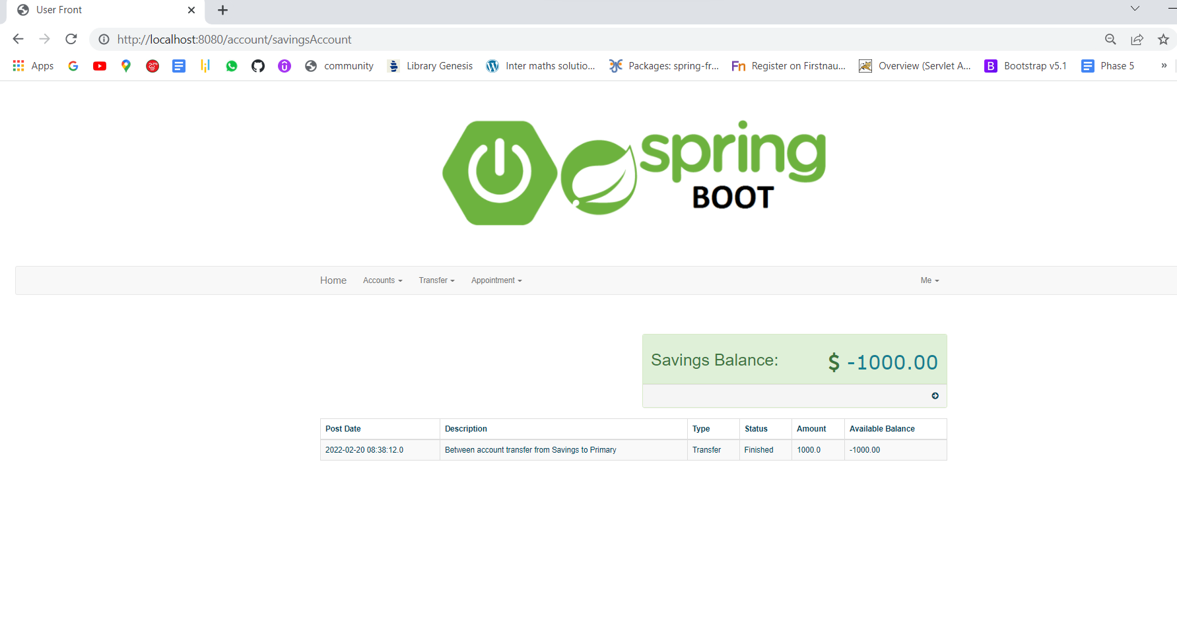

1. **PRIMARY SAVINGS:**

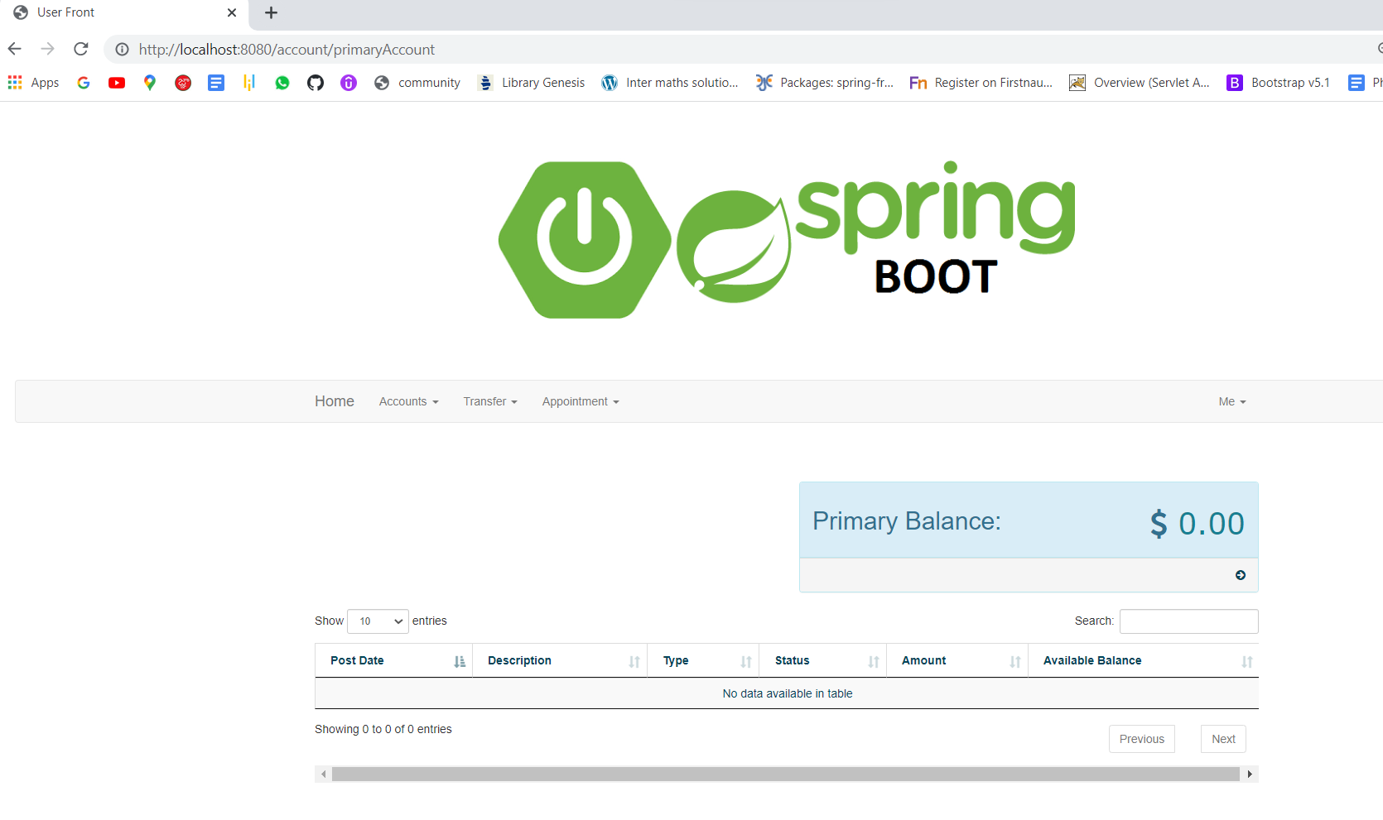

1. **SAVINGS:**

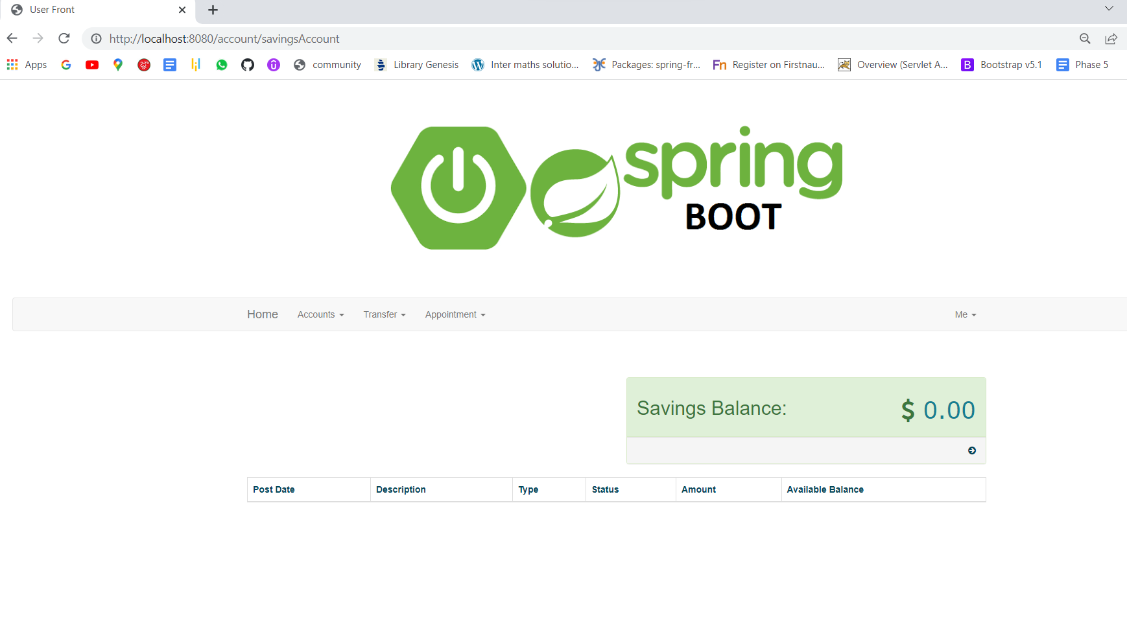

1. **ME OPTION:**

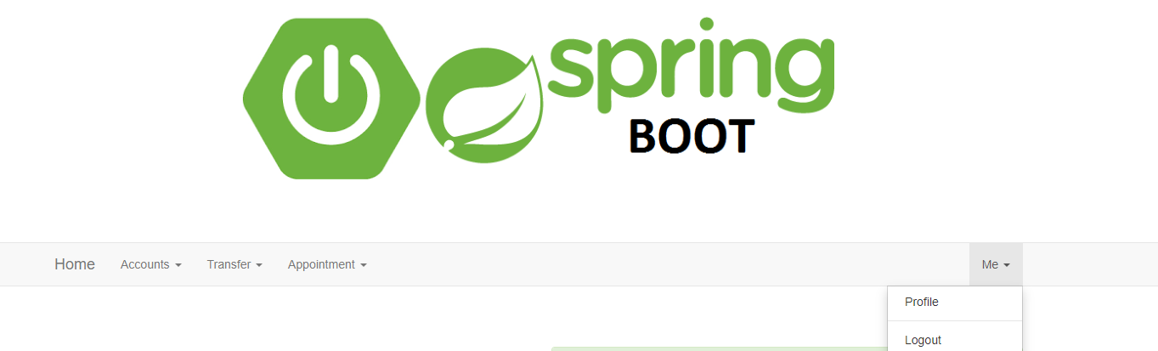

1. **PROFILE:**

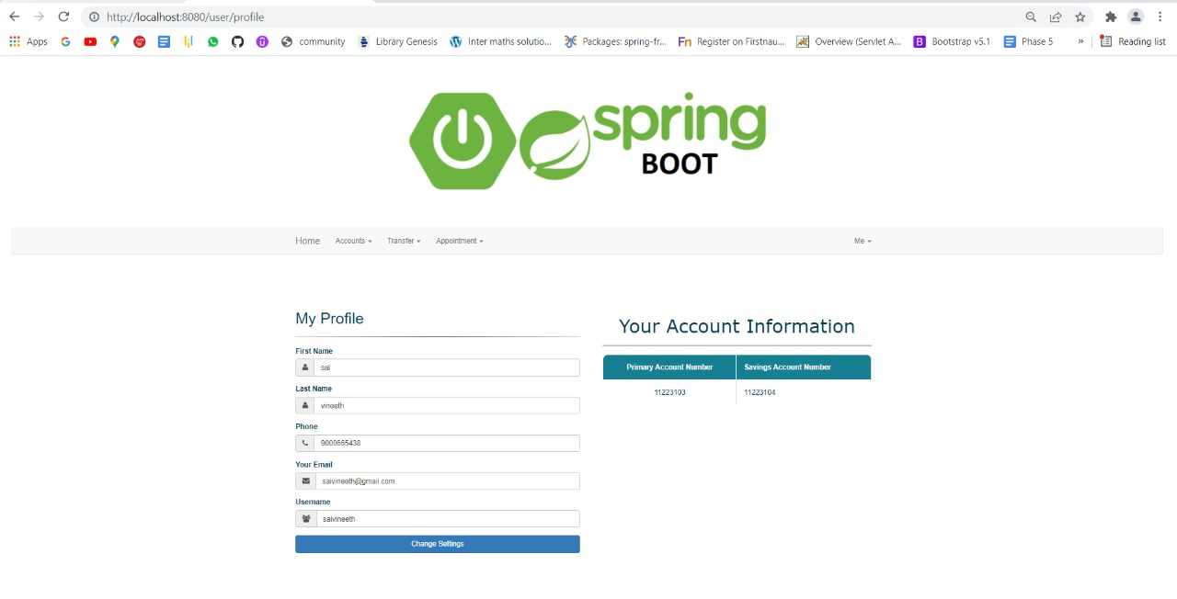

1. **RECEPTION ADDING:**

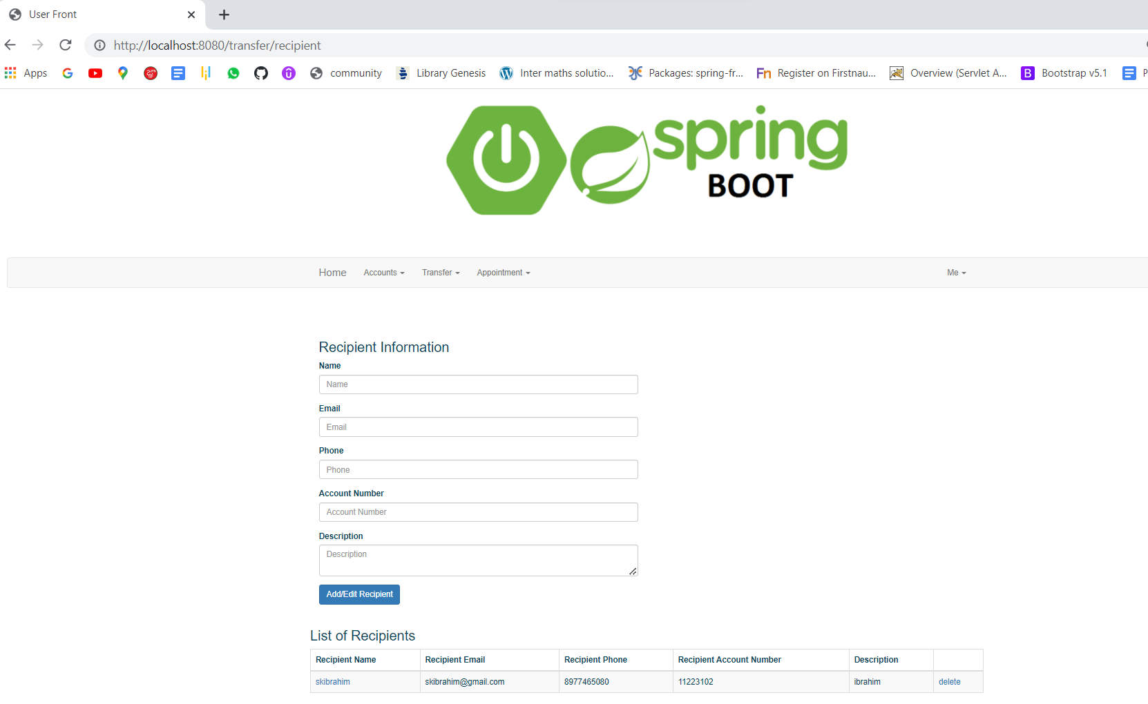

1. **SCHEDULE APPOINTMENT:**

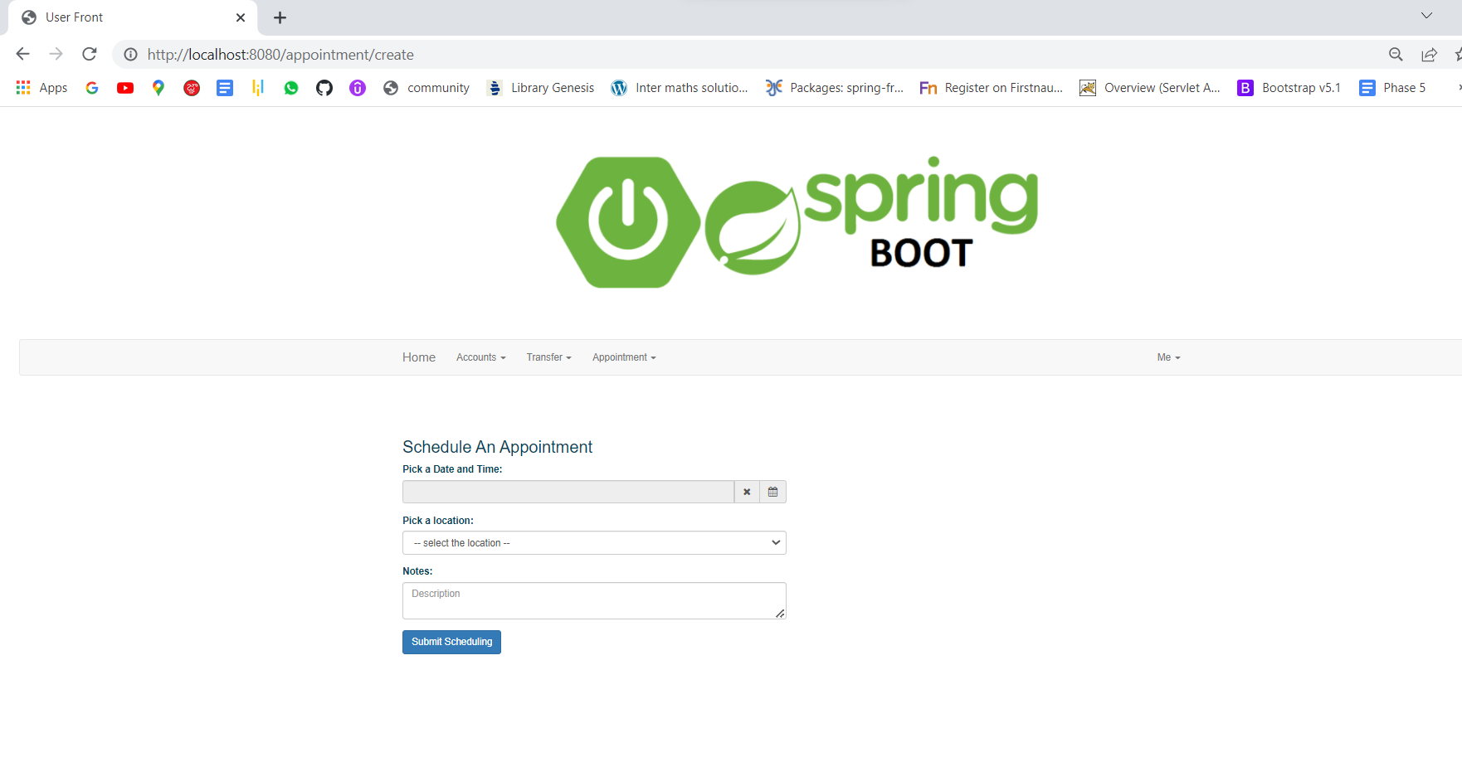

# 

# **23. ADDING RECEPTIONS:**

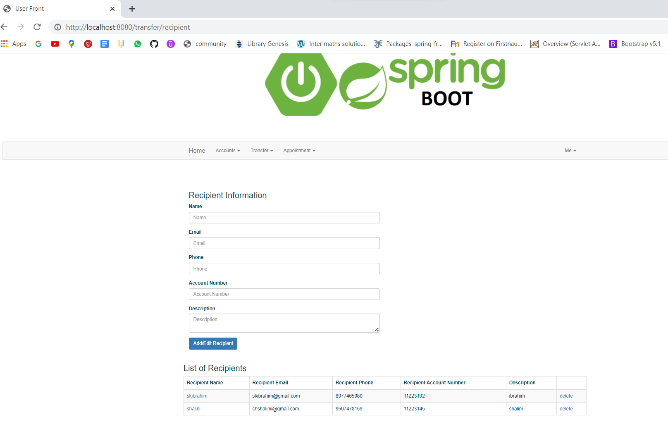

# **24. WITHDRAWN:**

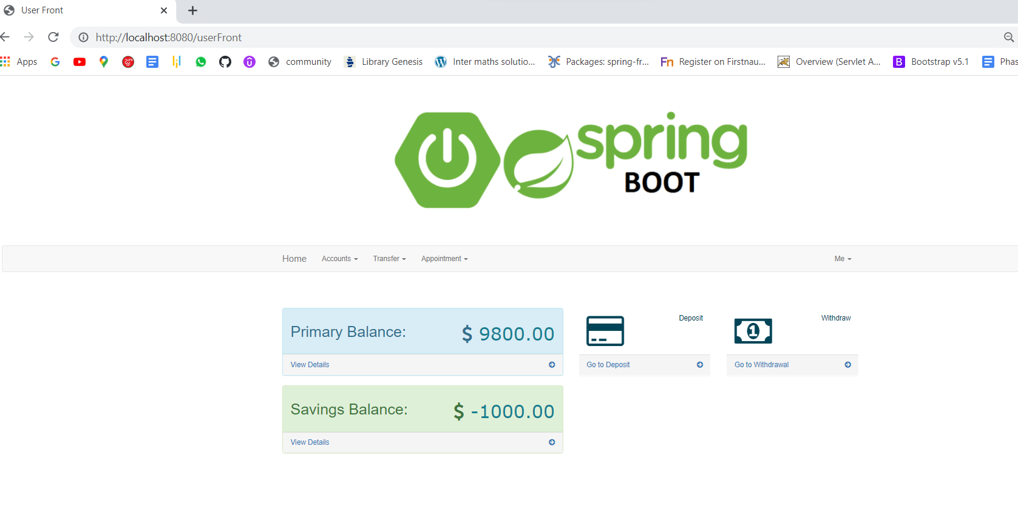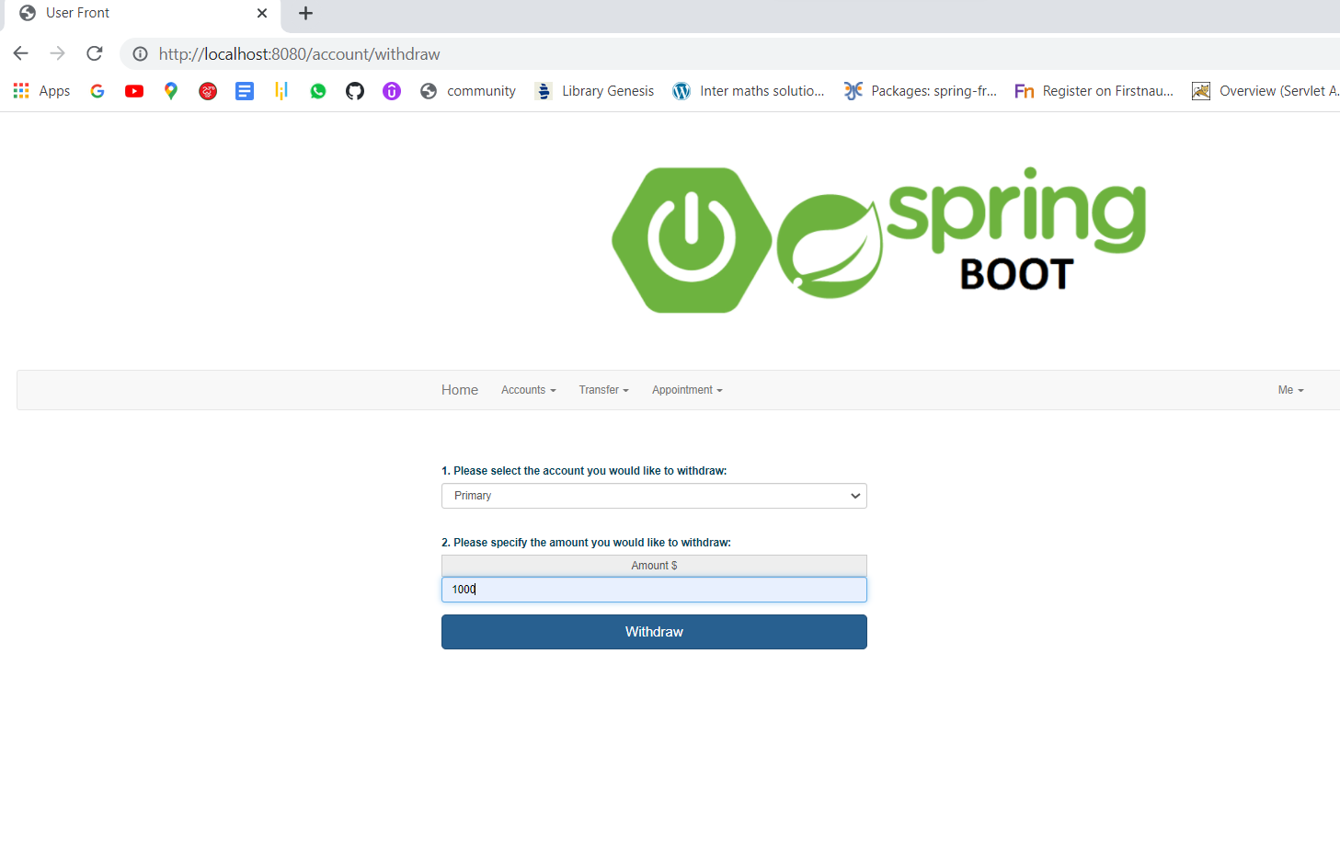

# **--------------------THE END--------------------------**

THANK YOU SIMPLILEARN  
 TATA SAI VINEETH